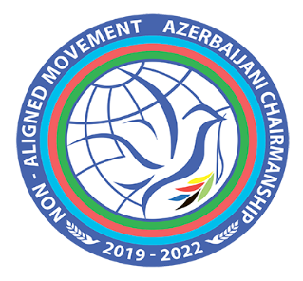

Online International Model
Non-Aligned Movement Simulation Exercise
Dedicated to the 60th Anniversary of the Non-Aligned Movement
1-5 March 2021

Online Workshop Program
(Baku time, GMT+4)
Topic | Date and time | Presenter  (short biography is attached)
Part 1 - Introduction to the Non-Aligned Movement  Part 2 - Basics of Diplomatic Correspondence  Part 3 - Diplomatic Negotiations in Practice  Part 4 - Work of Media during the Simulation Exercise | 1 March  16:00 – 19:00 | Mr. Yalchin RAFIYEV,  Head of International Security Department, Ministry of Foreign Affairs of the Republic of Azerbaijan
Online Simulation Exercise Program
(Baku time, GMT+4)
2 March 2021
15:30-16:00 | Connection and quality test
16:00 – 16:30 | Opening and key note remarks  - H.E. Mr. Jeyhun BAYRAMOV, Minister of Foreign Affairs of the Republic of Azerbaijan  - Ms. Jayathma Wickramanayake, UN Secretary General’s Envoy on Youth (TBC)
16:30 – 18:30 | Plenary session (initial reactions to the situation)
18:30 – 19:30 | Bilateral/multilateral negotiations – formation of groups/alliances
19:30 – 20:30 | Media briefing
20:30 – 22:30 | Focus Group Discussion among NAM Member States represented by participants from Latin American Region
3 March 2021
12:00 – 14:00 | Focus Group Discussion among NAM Member States represented by participants from Asia Region
14:00 – 16:00 | Focus Group Discussion among NAM Member States represented by participants from European and African Regions
16:00 – 17:30 | Plenary / General discussions (reactions to the new developments)  - followed by circulation of the draft Declaration by the Chair
17:30 – 18:00 | Break
18:00 – 19:00 | Bilateral/multilateral negotiations
19:00 – 20:00 | Media briefing
20:00 – 22:00 | Focus Group Discussion among NAM Member States represented by participants from Latin American Region
4 March 2021
12:00 – 14:00 | Focus Group Discussion among NAM Member States represented by participants from Asia Region
14:00 – 16:00 | Focus Group Discussion among NAM Member States represented by participants from European and African Regions
16:00 – 18:00 | Plenary / circulation of the zero draft version of the outcome document by the Chair / Drafting
18:00 – 19:00 | Bilateral/multilateral negotiations
19:00 – 20:00 | Media briefing
5 March 2021
16:00 – 17:00 | Pre-drafting informal negotiations
17:00 – 19:00 | Plenary / Drafting and Adoption of the outcome document
19:00 – 20:00 | Media briefing
20:00 – 21:00 | Conclusion of the event / closing remarks by the representative of the MFA of Azerbaijan / Certification Ceremony

