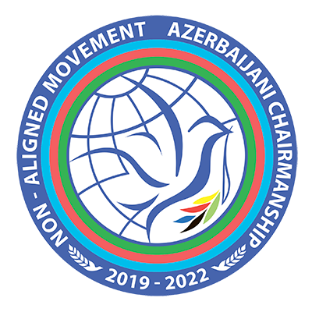

Online International Model
Non-Aligned Movement Simulation Exercise
Dedicated to the 60th Anniversary of the Non-Aligned Movement
1-5 March 2021

Procedural and Technical Modalities

1. Coordination: WhatsApp group will be established for facilitating communication among participants.

2. Meeting ID: Before the start of each day of the workshop and the simulation, the ID for the Zoom meeting will be shared in the Whatsapp group “NAM Model Participants”

3. Delegates will represent the assigned States in the capacity of Heads of State or Government during Plenary Sessions and in the capacity of Ministers of Foreign Affairs during Focus Group Discussions and Drafting Sessions.

Participants are requested to change their displayed names in Zoom software to the name of their assigned States and to add the emoji flags of their assigned States to the end of those displayed names. Displayed names can be changed either through editing the name and surname in participant’s Zoom profile by signing in to the account via www.zoom.us in the browser or through changing the displayed username for the specific meeting only. To change the name for the specific meeting, the following steps can be taken: “during the meeting click on Participants → bring the mouse to your actual username → More → Rename”. Alternatively, before the participant joins the meeting, Zoom application might ask her/him to type a username for joining the meeting, where the name of the assigned State could be written.

4. Opening Session: will start on 2 March, at 4:00 p.m. (Baku time, GMT+4), with the statements by the keynote speakers.

5. Plenary Session: will be opened by the Chair (participant representing Azerbaijan - incumbent chair of the Non-Aligned Movement) of the meeting followed by statements of other NAM Member States. Each delegation will have a right to speak for 2-3 minutes.

Delegations wishing to deliver statement at the plenary session should inform the Chair by sending a Note-Verbale (the participants will be trained how to compose a Note-Verbale at pre-simulation online workshops) on a day prior to the first plenary session, i.e. on 1 March via e-mail (contact list of all participants will be distributed).

At the end of the day of 1 March the Chair will distribute the list of speakers to all participants. If any participant will not see her/his name in the list, he/she should immediately contact the Chair for necessary adjustments.

6. List of speakers: The list of speakers for the Plenary Session will be made on a “first come, first served” basis.

Considering the technical features of Zoom software, delegates’ microphones must stay “Muted” during the sessions, unless they are given the floor to speak by the Chair.

Each delegate can speak only once during each plenary session. If the list of speakers is exhausted before the end of the session, the remaining time might be made available to deliver additional remarks.

7. Point of order: If one delegate violates the conduct of the meeting (f.e. engage in a non-constructive or disrespectful manner), any other delegate can raise “a point of order”. Delegates, who want to raise “a point of order” during the statement of another delegate, should type “Point of order” to the “General Chat of the meeting”. Pursuant to that request, the Chair will give the floor to the requesting delegation for delivering a “point of order”.

8. Right of reply is a right to defend oneself against accusation made by another delegate. At the end of each plenary session (if time allows) or during the next session, delegates will have the possibility to exercise their right of reply. Any delegate, who wishes to exercise this right should type “right of reply” to the “General Chat of the meeting”.

P.S. Please note that only those delegates whose names will be voiced out in the statement of another delegate in an insulted or otherwise degrading manner can request a right of reply.

9. Distribution of documents: Each Delegate can share documents related to the agenda of the exercise (their statements, position papers, MoUs, non-papers and etc.) via “File sharing” option at the “General chat of the Meeting”.

10. Bilateral meetings: Delegates are encouraged to hold separate bilateral and multilateral consultations and to form alliances during the time allocated for bilateral/multilateral negotiations. Delegates can choose any means (separate chats, Whatsapp messaging etc.) that are suitable for them to conduct such discussions.

11. Media briefing: Nine of the participants will be assigned the roles of media agencies. They will provide the media coverage of the deliberations during the time allocated for media briefing by a) interviewing delegates, b) organizing press-conferences, c) displaying news broadcasts or d) sharing advance prepared news articles.

Media representatives are recommended to ask each participant questions related to the discussions, either in written form and/or by asking them to answer questions through self-recorded video files.

Written answers must be placed in a template of respective news agency and distributed among the participants during media briefing part of the program. Recorded video files must be merged with presentation of respective correspondent and displayed as “News Broadcast” during media briefing part of the program (details will be explained at the online workshops).

12. Drafting session: In accordance with the prevailing content of the consultations during the plenary sessions, the Chair will prepare a draft outcome document for consideration and adoption by the Extraordinary Summit.

During the drafting sessions the delegates will consider and give proposals (if any) to the text paragraph-by-paragraph.

Each delegate will have the right to propose amendments and/or additions/removals to the suggested text. Delegates are recommended to formulate their proposals in exact wording and provide short explanation for their suggestions.

Delegate willing to suggest a proposal should type “request for the floor” in the “General Chat of the meeting”.

