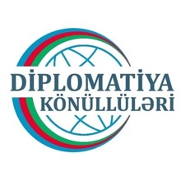
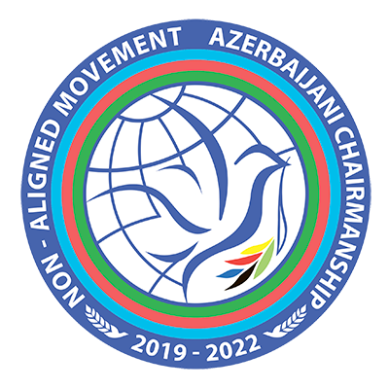
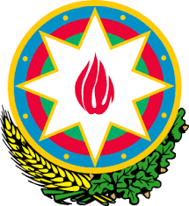

Ministry of
Foreign Affairs
Republic of Azerbaijan

Online Model Non-Aligned Movement
Simulation Exercise
in the framework of the “Year of Volunteers”
Co-organized by the Ministry of Foreign Affairs of the Republic of Azerbaijan and Diplomacy Volunteers
16-18 April 2020
Concept Note
- Background info on the Non-Aligned Movement
The Non-Aligned Movement (NAM) is the biggest political forum after the United Nations, composed by 120 Member States from all parts of the globe. Currently there are also 17 states and 10 international organizations holding an observer status (see Annex 1).
The Movement was formed during the Cold War, as a group of States that did not seek to formally align themselves with either of the confronting blocs, but sought to remain independent or neutral. It was officially founded in 1961, at the Belgrade Summit, drawing on the principles (also known as Bandung Principles – see Annex 2) agreed at the Afro-Asian Conference held in Bandung, Indonesia in 1955 that up to date still serve as the purposes and objectives of the policy of non-alignment.
At the beginning, the Movement, its actions and endeavors constituted a key factor in the processes of decolonization, which then led to the achievement of the freedom and independence of many countries and peoples, and to the formation of new States that later became part of it.
Throughout its history, the Movement has played an important role in strengthening international peace and security, within the framework of its permanent quest for establishing a more peaceful and prosperous world. It persistently called for strict adherence to the norms and principles of international law and has provided major thrusts in the areas of disarmament, better economic wellbeing, social justice and environmental sustainability.
NAM does not have a formal constitution or permanent secretariat, and its administration is non-hierarchical and rotational. Decisions are made by consensus.
Summit Conference of the Heads of State and Government of the NAM is the highest decision-making body of the Movement. The Summits are held in every three years. At each Summit, a new Head of State formally becomes the chairperson of the NAM, and assumes that position until the next Summit. The chair is responsible for promoting the principles and activities of NAM, while the Foreign Ministry and Permanent Mission in New York of the Chair's State assumes administrative responsibility.
- Online Model Non-Aligned Movement (NAM) Simulation Exercise
As the world continues to struggle Coronavirus infection (Covid-19) which was declared as pandemic by the World Health Organization, all events at the national and/or international level are being either postponed or cancelled.
At this critical juncture, given the necessity of ensuring continuity in the learning process of Azerbaijani youth and as yet another contribution to the “stay at home” public campaign as part of social isolation measures, Ministry of Foreign Affairs of the Republic of Azerbaijan and its “Diplomacy Volunteers” are going to organize first-ever online Model NAM Simulation Exercise on 16-18 April 2020.
Besides afore-mentioned, the event will be part of series of events planned under the Chairmanship of Azerbaijan to the Non-Aligned Movement
It will be an academic simulation of the Non-Aligned Movement where the participants play the roles of delegates from different NAM Member States and attempt to solve real world issues with the policies and perspectives of their assigned country. It will help the participants to get more acquainted with the political dynamics prevailing within the Movement and to strengthen their negotiations and problem-solving skills.
It will also enable the participants to better understand the interests, concerns and sensitivities of individual NAM Member States concerning certain issues of global agenda.

- Format of the Exercise
Given the current circumstances with regard to the Covid-19 pandemic and in line with requirements of the Cabinet of Ministers the event will be held on line where the participants will join the online simulation debate through specific software program (Zoom, Adobe Connect or Google Hangout).
The participants will meet at the online simulated format of the Extraordinary Summit of the Heads of State and Government of NAM and hold consultations over a fictitious scenario-based crisis situation related to one or more NAM Member States. The consultations will be followed by the adoption of political decision.
A week before the event, the participants will receive instructions on technical requirements for joining the simulation, as well as information on simulation scenario. In the course of last 3 days before the event, the participants will pass online pre-simulation preparatory period which will include testing of individual technical capabilities of each participant, as well as the explanatory online workshops on Non-Aligned Movement, the format and tactics of negotiations, tips for drafting national statements and preparing draft decisions, building alliances and communication with media.
On the first day of the exercise, the participants will receive info on the general description of the crisis situation. It will later be followed by several common and individual instructions, as the consultations and negotiations advance.
The delegates will be encouraged to hold, through the same or other online chatting options, separate bilateral and multilateral consultations and to conclude MoUs.
Some of the participants will be assigned the roles of independent media agencies that will provide the media coverage of the deliberations by interviewing delegates, organizing press-conferences and displaying news broadcasts. Media representatives will be able to ask each participant to record his/her own video in response to the advance questions submitted by the respective media agency and send it to the latter for distribution.
Based on the prevailing content of two-day consultations, the chairing country will prepare a draft final decision for the consideration and adoption of the Extraordinary Summit.
Online preparatory period
Online consultations
Adoption of decision

Number of delegations: 30
Number of media representatives: 8
Supervisors: 2
Total: 40

- Selection process
The participants of the Online Model NAM Simulation Exercise will be selected among the nominees presented by the Volunteer Organizations of the Republic of Azerbaijan based on the competitive application procedure.
Application process is consisted of application form (including motivation letter) and if needed, followed by skype/phone interview.
Members of Volunteer Organizations between the ages of 18 and 29 are invited to apply for the event by filling out the application form no later than 5 April 2020.
Filled application forms should be sent to the following email address: nammodelazerbaijan@gmail.com
Any applications received after the set deadline will not be considered by the Selection Committee.
Selection Committee will be composed of the representatives of the Ministry of Foreign Affairs of the Republic of Azerbaijan and Diplomacy Volunteers.
The short-listed applicants identified based on their educational and professional backgrounds, as well as English language proficiency and expressed motivation for attendance, will be contacted by the Selection Committee for an interview. Successful candidates will receive invitation letter to attend the Exercise.
The exercise will be conducted in English. Therefore all nominees should have an excellent command of English in both writing and speaking.

- Certificates
All participants will receive certifications of attendance.
Most successful participants will get the chance to participate, without selection process at the International Model NAM Simulation Exercise, which will be held later in 2020 in Azerbaijan.

For any further inquiries please contact the following email address: nammodelazerbaijan@gmail.com

